

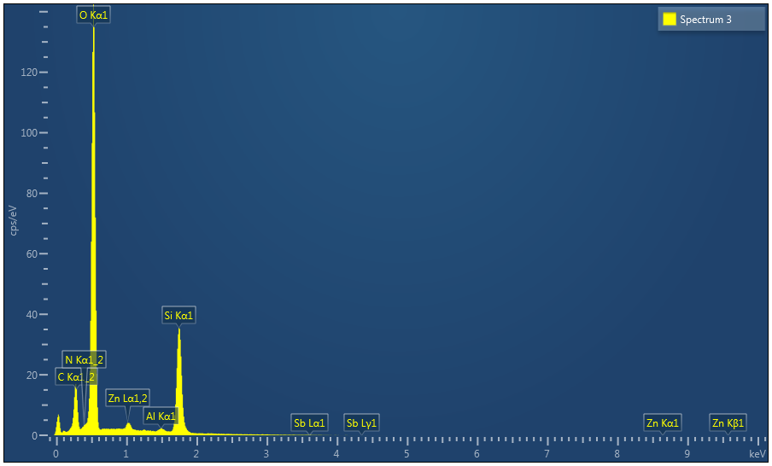

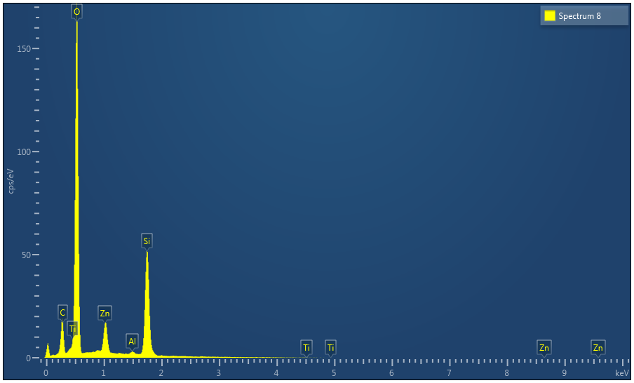

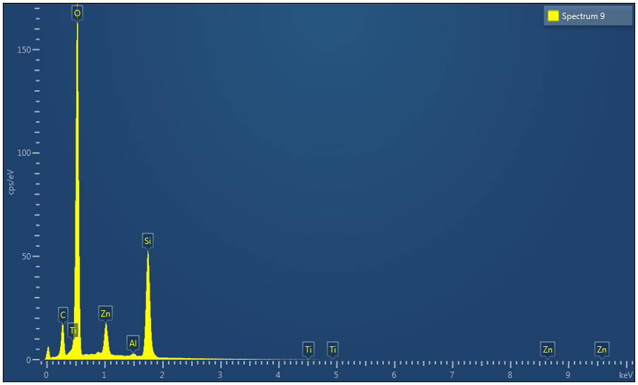

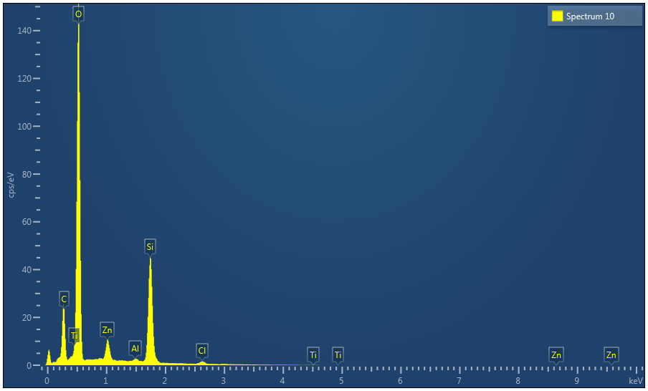

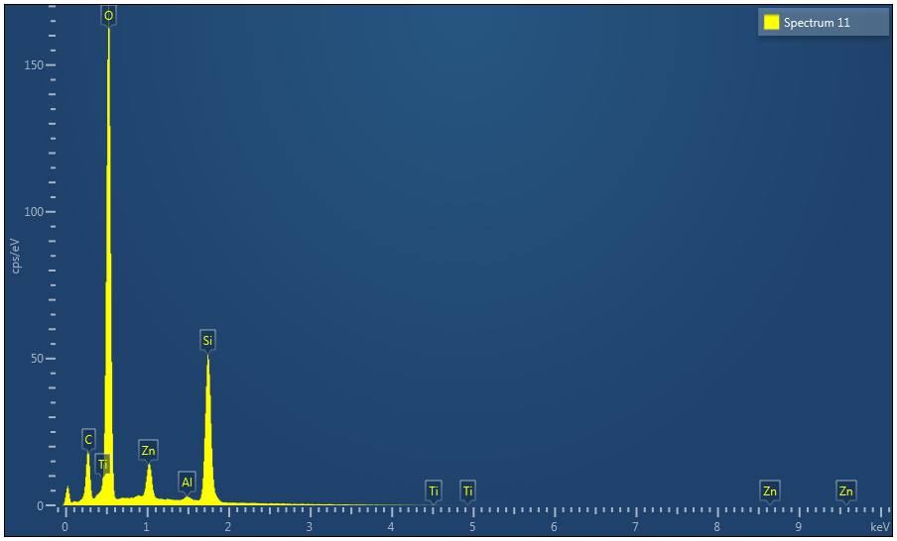

|  |  |
| --- | --- |
| Result Type | Atomic % |

|  |  |  |  |  |  |
| --- | --- | --- | --- | --- | --- |
| Spectrum Label | Spectrum 3 | Spectrum 8 | Spectrum 9 | Spectrum 10 | Spectrum 11 |
| C | 12.55 | 9.65 | 9.49 | 15.20 | 10.03 |
| N | 1.10 |  |  |  |  |
| O | 64.07 | 60.30 | 60.50 | 57.21 | 60.69 |
| Al | 0.48 | 0.40 | 0.41 | 0.36 | 0.40 |
| Si | 21.20 | 21.65 | 21.98 | 20.21 | 21.54 |
| Cl |  |  |  | 1.24 |  |
| Ti |  | 5.57 | 5.11 | 4.31 | 5.34 |
| Zn | 0.54 | 2.43 | 2.52 | 1.46 | 2.01 |
| Sb | 0.06 |  |  |  |  |
| Total | 100.00 | 100.00 | 100.00 | 100.00 | 100.00 |

|  |  |  |  |  |  |  |  |  |  |
| --- | --- | --- | --- | --- | --- | --- | --- | --- | --- |
| Statistics | C | N | O | Al | Si | Cl | Ti | Zn | Sb |
| Max | 15.20 | 1.10 | 64.07 | 0.48 | 21.98 | 1.24 | 5.57 | 2.52 | 0.06 |
| Min | 9.49 | 1.10 | 57.21 | 0.36 | 20.21 | 1.24 | 4.31 | 0.54 | 0.06 |
| Average | 11.38 |  | 60.56 | 0.41 | 21.32 |  |  | 1.79 |  |
| Standard Deviation | 2.47 |  | 2.43 | 0.04 | 0.68 |  |  | 0.81 |  |